Step1.
1-1: If you are an AC power system user, please insert the two red plugs in both red sockets, and also insert the black plug in the middle way black socket.
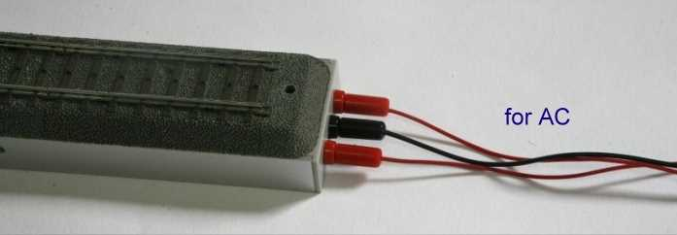

1-2: If you are a DC power system user, please insert one red plug into the right red socket (if the engine didn’t run, you need to swich to left side red socket), and insert the black plug into the middle way black socket.
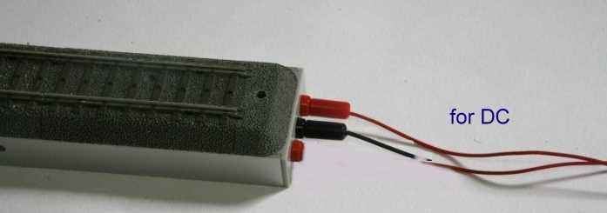

Step2. Insert the wire into the both side hole.
